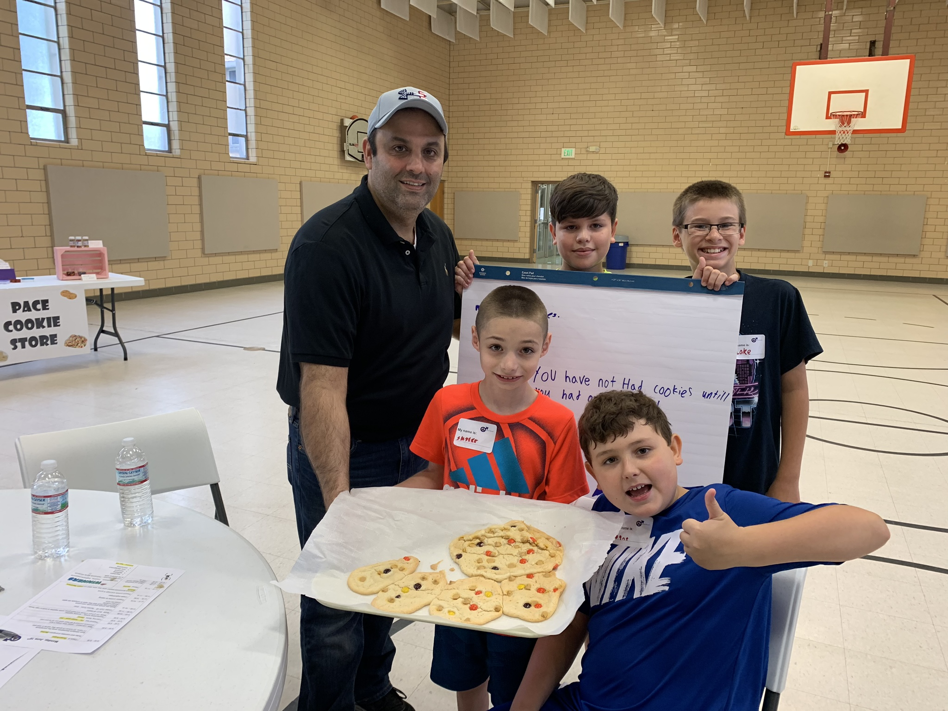  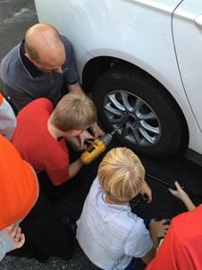  Boys & Beyond  NO COST!  Boys & Beyond  SUMMER CAMP  July 8 – July 12, 2024  8 AM - Noon  Application Deadline - June 14th!  Acceptance Letters will be mailed | For boys finishing the 4th and 5th grade  ────  No Cost  Lunch Provided  ────  Activities include: • Car Care  • Computer Care  • Personal Hygiene  • Negotiation  • Presentation  • Managing Money  ────  Boys in Daviess, Greene, Knox & Sullivan Counties are eligible to apply  Located at Pace CAA  525 N 4th St  Vincennes, IN  (812) 882-7927  www.pacecaa.org/boys-and-beyond  Questions? hmincey@pacecaa.org

